
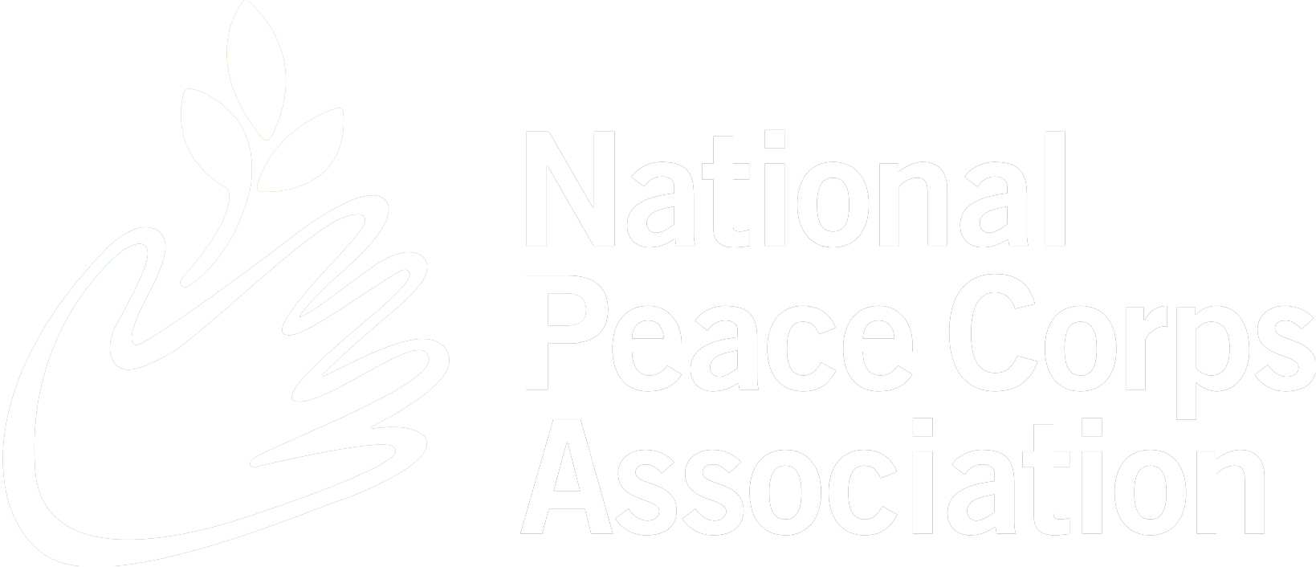
Peace Corps:
Good for the World
Good for North Carolina


The Peace Corps Community in North Carolina
North Carolina Peace Corps Volunteers Through the Years
NORTH CAROLINA
VOLUNTEERS 4,997 2020: 217 2017: 230
SINCE 1961
2019: 229 2016: 214

2025 2018: 230 1966: 127
NORTH CAROLINA 114
VOLUNTEERS

5 Things to Know about the Peace Corps Community in North Carolina

North Carolina currently ranks 11th in the nation, sending approximately 110 Peace Corps Volunteers overseas.

Peace Corps has educational partnerships with Appalachian State University, Duke University, Elon University, Fayetteville State University, North Carolina Central University, UNC-Wilmington, UNC-Pembroke, and Wake Forest University.

National Peace Corps Association affiliate groups include the Charlotte Area Peace Corps Association, the Coastal Carolina Returned Peace Corps Volunteers (RPCVs), the North Carolina Peace Corps Association, the Winston–Salem RPCVs, and the Western North Carolina RPCVs.

Fundraising by the Western North Carolina RPCVs allowed the group to purchase 200 quality children’s books and donate them in 2025 to the Literacy Together Education Center in Asheville.

For more than 20 years, the North Carolina Peace Corps Association has awarded its North Carolina Peace Prize, which honors small, community based groups that honor the values of the Peace Corps. The 2026 Peace Prize was awarded to the East Wake Education Foundation, which – since 1993 - has provided free preschool and enrichment programs to children from low income families in eastern Wake County.

*Based on data from Peace Corps, National Peace Corps Association, and other news sources.

